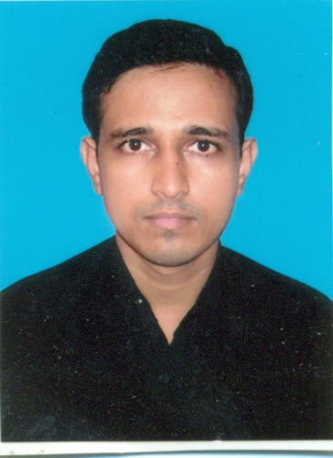
CURRICULUM VITAE

MD.NISHAT

Mobile: +919007447820 Email: nishat_chess@yahoo.com
Address: 3/3A, Narkeldanga Main Road, Kolkata-700011
Passport No. : J6824186 Date of Expire: 12/05/2021
PAN No. : AIYPN8653Q

To get placement in an organization where I can explore my strengths and develop my skills to my utmost capability and hence contribute effectively to the development of the organization.

STRENGTHS

- Positive Outlook
- Endowed with good entrepreneurial skills as well as a keenly observant and an analytical mind.
- Team player with the ability to deliver effectively under high-pressure environments.
- Patient and persevering with good communication and organizational skills.
- Self Motivated and Result Oriented

ACADEMIC CREDENTIALS

- Graduation from Calcutta University.
- 12th from (W.B.C.H.S.E), Kolkata, West Bengal, India.
- 10th from (W.B.B.S.E), Kolkata, West Bengal, India.

WORK EXPERIENCE

- Currently I am working for DHL Express (I) Pvt. Ltd. as a Telecom Admin Payroll of Taurus Facility Management Services.
- Having experience as an Assessor and assessed PMKVY, ESSCI exams for the batches of Electronics.
- Worked for DHL Express (I) Pvt. Ltd. as a Jr. Telecom Engineer in payroll of Anjani Telecom Services at Kolkata Location from 10th March 2012 to 31st Jan. 2015.
- One year as a freelancer Computer Hardware & Network Engineer in the name of BINARY Computer Services.

PROFESSIONAL QUALIFICATION

- RHCSA Global from WEBEL INFORMATICS LTD, Kolkata, W.B.
- CompTia A+ Certified from NIIT, Kolkata.
- Certificate Course in Industrial Accounting System from ICA Sealdah, Kolkata.
- Certificate Course in CCTV Installation and Maintenance.

KEY SKILLS

- Good knowledge in Cisco IP Phones Configurations & Others.
- Well versed in all basic computer operations & MS office applications, likes Power point, Excel, Word & productive software’s.
- Good knowledge in Rj45 & Rj11 cabling and Lan & Wi-Fi Networking etc.
- Well versed in Computer Hardware and Networking Troubleshooting.
- Basic Working Knowledge about Tally, Accord & Fact.
- Well versed in revenue generation activities, i.e., Sales oriented and marketing jobs.
- Basic Knowledge about CCTV Installation and Maintenance.
- Well versed in WINDOWS 98, WINDOWS XP, 7, VISTA and Windows Server 2003 with Microsoft Package etc. Installing, Assembling & Total Hardware Solution with LAN Networking.

INTERESTS

- Playing chess, Trekking, Mountaineering & Champing.

AREAS OF INTEREST

- System Administrator
- Telecom Technician
- Marketing & Sales
- Technical support services for consumer products
- Computer Hardware & Networking

PERSONAL DETAILS

Date of Birth : 31th March 1991
Father’s Name : Md.Shamshad
Gender : Male
Nationality : Indian
Religion : Islam
Marital Status : Unmarried
Physical Status : Possess a good and sound health
Languages known : Hindi, English, Urdu & Bengali
Correspondence : 3/3A/H/19/2 Maulana Abdul Kalam Azad Sarani, Kolkata – 700011
West Bengal, India.

Declaration

I consider myself familiar with my own job. I am also confidence of my ability to work in a team.
I hereby declare that information furnished above is true to the best of my knowledge.

Date:-

Place:-

___________________
Md.Nishat

